**Exercise 7: Financial Forecasting**

**Understand Recursive Algorithms:**

Recursion is when a method calls itself to solve a smaller version of the original problem.

**Output:**

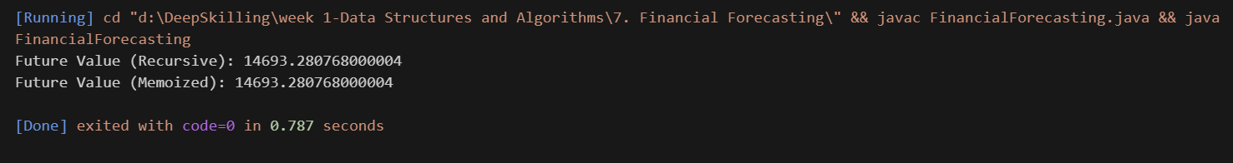

**Analysis:**

* **Time Complexity:**

1. Simple Recursion: O(n)
2. Memoized Recursion: O(n)

* **Optimization Strategy:**
  + **Memoization**: Store already computed values.
  + Alternatively, use **iteration** for better space usage (O(1) memory).